**White Box Testing**

Code

Control Flow Graph

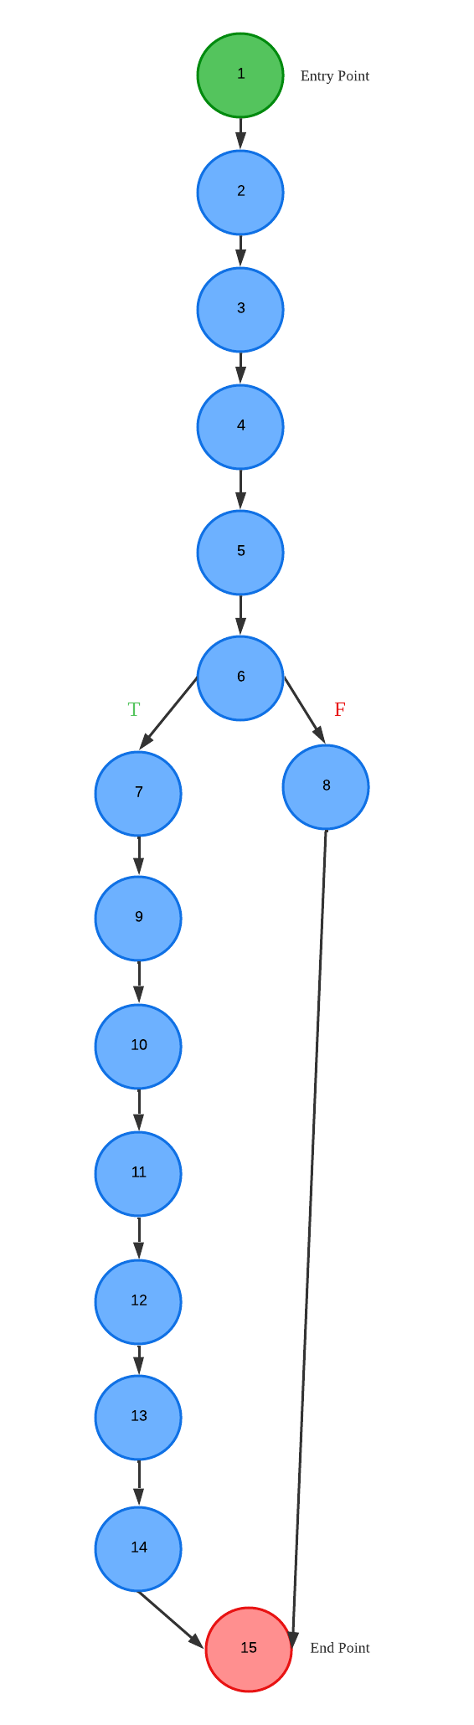

Cyclomatic Complexity

M = 15 - 15 + 2(1) = 2

Basis Path

Path 1: 1 - 2 - 3 - 4 - 5 - 6 - 7 - 9 - 11 - 12 - 13 - 14 - 15

Path 2: 1 - 2 - 3 - 4 - 5 - 6 - 7 - 8 - 15